## Install Vue Js via NPM

npm install -g @vue/cli

npm install -g @vue/cli-init

## Create Vue Project via Command

vue init webpack vueapp

Project name vueapp

? Project description

? Author Dharmendra Nama <51943113+DRajaNama@users.noreply.github.com>

? Vue build standalone

? Install vue-router? Yes

? Use ESLint to lint your code? No

? Set up unit tests No

? Setup e2e tests with Nightwatch? No

? Should we run `npm install` for you after the project has been created? (recommended) npm

vue-cli · Generated "vueapp".

## Run Vue Project

cd vueapp

npm run dev

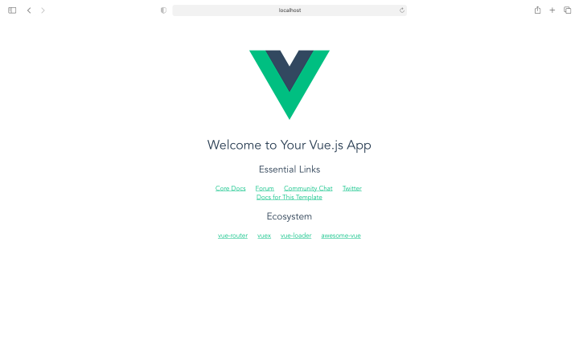

## Go browser and Run

localhost:8080

## Folder Structure of Vue Project

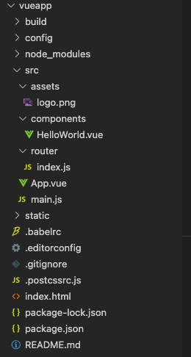

## IMG_256Work Flow and Life Cycle Of Vue Js Component

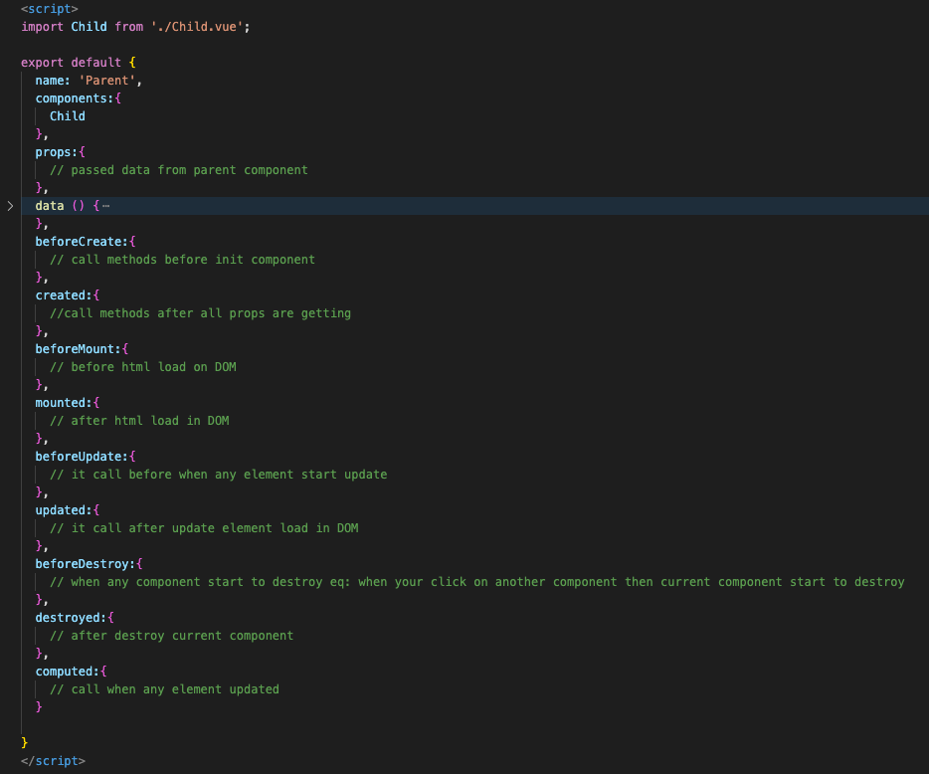

## Call Api in Vue Component via Axios

npm install --save axios

## Screenshot 2023-02-09 at 4.50.41 PMCreate Global prototype for axios

## Use Prototype in Component

## Screenshot 2023-02-09 at 4.52.41 PM

## Binding Data in html with v-model , v-for

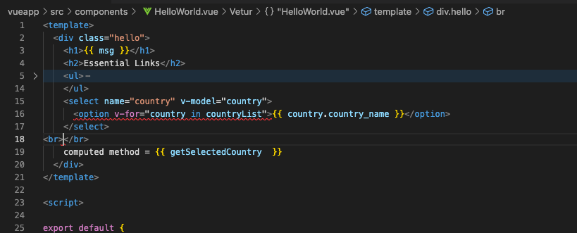

## Child Parent Relationship and data sharing way

## Screenshot 2023-02-09 at 5.15.28 PM

## Install Vuex and Use Store by Helpers

npm install --save vuex@3.1.0

## Create Store.js File for perform actions

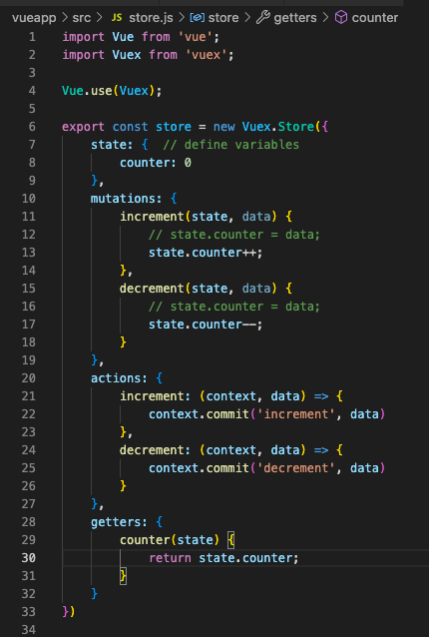

## Attach Vuex Store to the main.js Screenshot 2023-02-09 at 6.27.03 PM

## Use of Store in Component

